**Test Case 1 – Test basic flow of creditdetailsEntered function**

Description: Test evaluates the process of charging from card for the booking, after the process hotel should be booked with the room and debit amount should be displayed.

Pre-conditions: Booking control state should be credit. Card should be authorized. Room should be available

Post-conditions: Amount should be debited from card, state should be complete, complete booking details should be displayed.

Data required: authorized card, booking with credit state.

Test run:

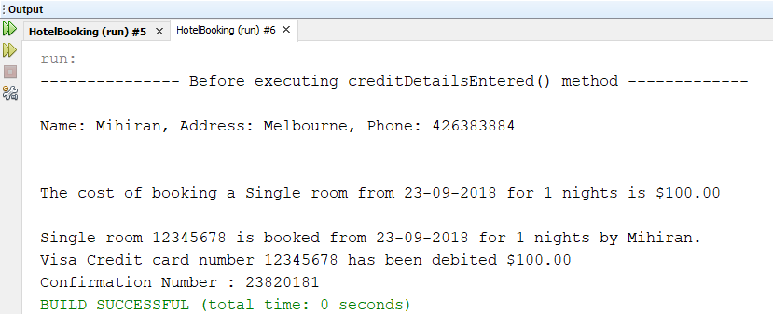

**Test Case 2 – Test the creditdetailsEntered function without adding a room**

Description: Test evaluates what happens when room is not available, a message should be displayed with proper error message.

Pre-conditions: There should be no rooms available,

Post-conditions: error message saying no available rooms

Data required: A hotel with no available rooms.

Test run:

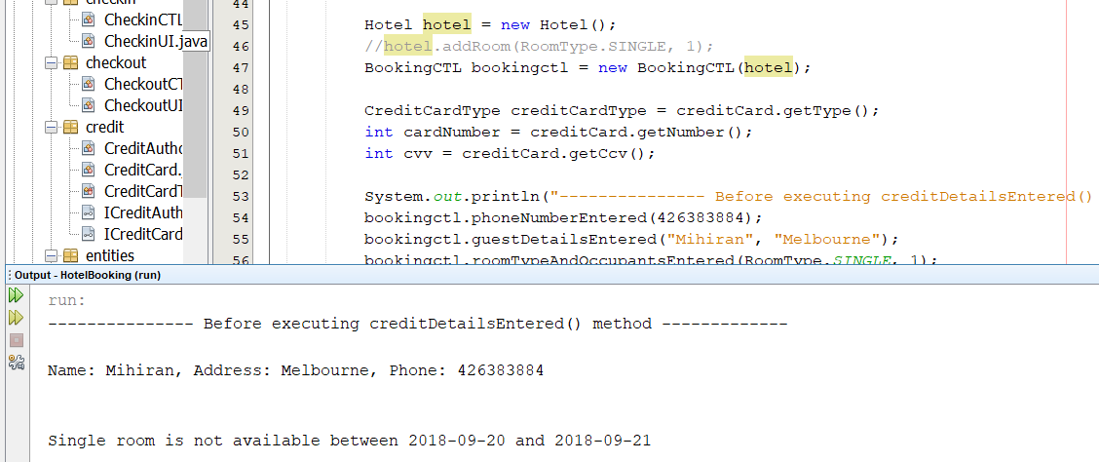

**Test Case 3 – Test the exception when state is not credit**

Description: Test evaluates what happens when booking state is not credit when calling **creditdetailsEntered** function, an exception should be thrown.

Pre-conditions: Booking state should not be credit

Post-conditions: an exception should be thrown

Data required: A booking with status not credit.

Test run:

